EXPERIMENT NO 30:

Design NFA to accept any number of a’s where input={a,b}.

AIM:

Design NFA to accept any number of a’s where input={a,b}.

INPUT:

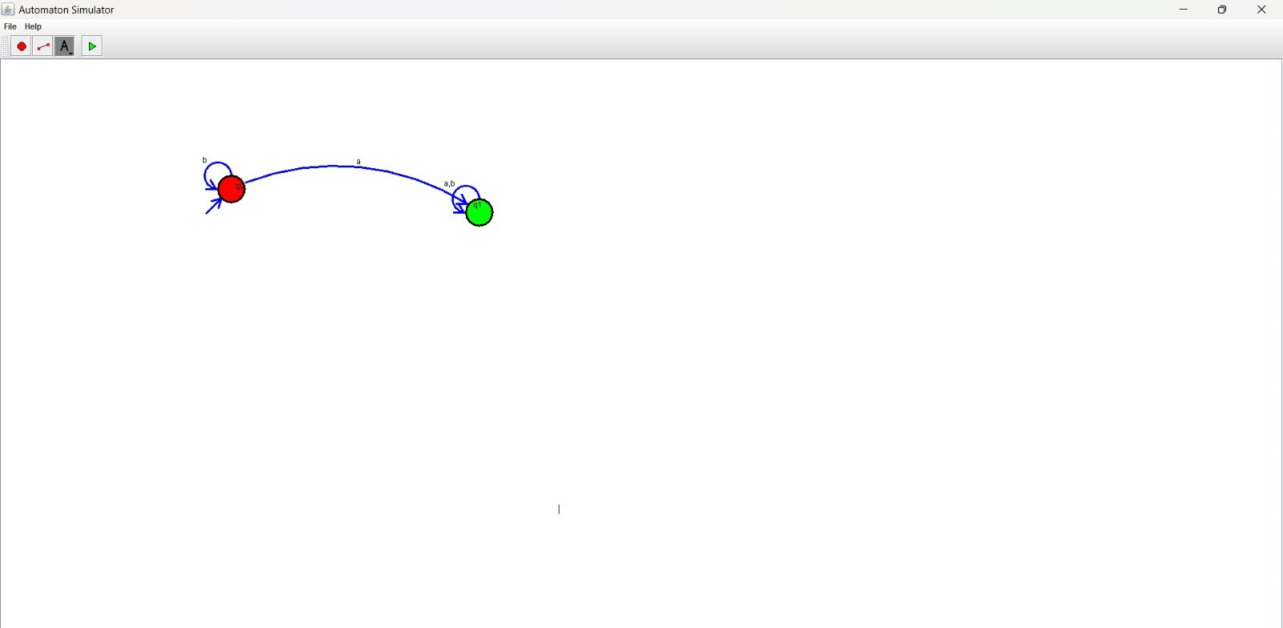

OUTPUT:

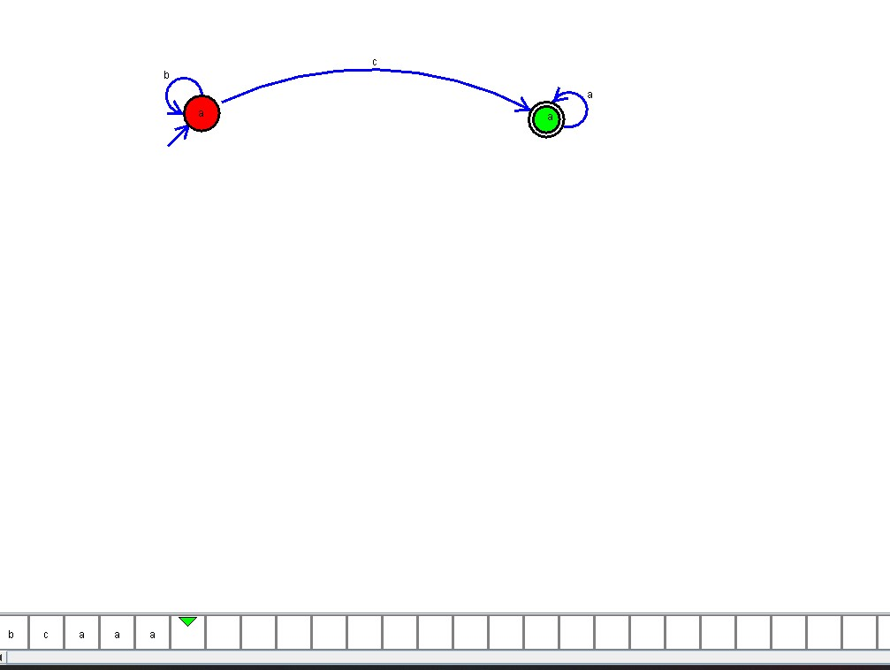

RESULT:

Thus the program was executed successfully.